|  |  |  |  |  |  |  |
| --- | --- | --- | --- | --- | --- | --- |
|  | Narrogin Senior High School | | | | | |
| **CHEMISTRY UNIT 1 & 2** | | | | | | |
| **Test #1:** | | | | | | |
| **Atomic Properties & Structure** | | | | | | |
|  | | | | | | |
| **NAME:** | | |  | | | |
|  | | |  | | | |
| **Time allowed for this paper** | | | | | | |
| Reading time: | | 5 minutes | | | | |
| Working time: | | 50 minutes | | | | |
|  | | | | | | |
| **Structure of this paper:** | | | | | | |
| Section | | | Number of questions | Marks available | | Marks achieved |
| Section One: Multiple Choice | | | 11 | 11 | |  |
| Section Two: Short Answer | | | 7 | 39 | |  |
|  | | |  | | **Total** | ______ / 50 |

**Section One: Multiple Choice**

This section has 11 questions. Answer **all** questions by circling the correct option. If you make a mistake, put a cross through your answer and then circle your new answer. No marks will be given if more than one answer is completed for any question.

Suggested working time: 10 minutes

1. What determines the type of element that an atom will be?
   1. Its electric charge
   2. Its electron configuration
   3. Its number of neutrons
   4. Its number of protons
2. Which of the following describes the force acting between electrons and the nucleus?
   1. Strong nuclear force
   2. Weak nuclear force
   3. Electrostatic attraction
   4. Electrostatic repulsion

**Questions 3 & 4 refer to a particular atom represented with the atomic symbol: ${}_{7}^{15}X$**

1. Which of the following is the correct electron configuration of element X?
   1. 2,5
   2. 2,6
   3. 2,7
   4. 2,8,5
2. What would be the formula of ions formed from element X?
   1. X3+
   2. X3–
   3. X+
   4. X–
3. What criteria is used to sort elements within a period?
   1. Atomic number
   2. Number of valence electrons
   3. Relative atomic mass
   4. Number of occupied electron shells
4. Which of the following statements gives the correct meaning of ‘electronegativity’?
   1. The ability of an atom to accept an electron to form a negatively charged ion
   2. The ability of an atom to attract electrons and form bonds with electrons
   3. The energy required to remove an electron from the atom in the gas phase
   4. The energy released when an electron is added to the atom in the gas phase
5. A **polar covalent bond** is a bond formed when two atoms with different electronegativities share a pair of electrons. The larger the difference in electronegativity, the greater the polarity of the bond.

Which combination of atoms would form the most polar bond?

* 1. Two fluorine atoms bonded together
  2. A fluorine atom and an iodine atom
  3. A fluorine atom and a bromine atom
  4. A fluorine atom and a chlorine atom

1. Which of the following correctly lists the order of steps that occur in a mass spectrometer?
   1. Acceleration 🡪 Ionisation 🡪 Deflection 🡪 Detection
   2. Ionisation 🡪 Acceleration 🡪 Deflection 🡪 Detection
   3. Ionisation 🡪 Deflection 🡪 Acceleration 🡪 Detection
   4. Acceleration 🡪 Deflection 🡪 Ionisation 🡪 Detection
2. Which of the above four steps in mass spectrometry involves the use of an electromagnet?
   1. Acceleration
   2. Ionisation
   3. Deflection
   4. Detection
3. During a flame test, a bright red flame is observed. Which of the following salts would be consistent with such an observation?
   1. Copper(II) sulfate
   2. Potassium chloride
   3. Sodium nitrate
   4. Strontium nitrate
4. The following diagram shows emission spectra for four elements and an unknown sample.

Helium:

Hydrogen:

Sodium:

Mercury:

Unknown:

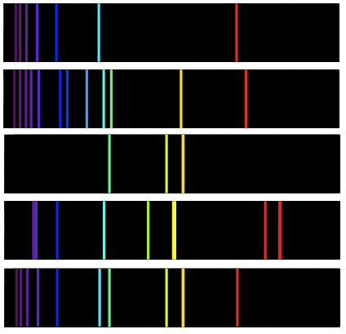

Which option in the table below correctly identifies whether or not hydrogen, helium, sodium and mercury are present in the unknown sample?

|  |  |  |  |  |
| --- | --- | --- | --- | --- |
|  | **Hydrogen** | **Helium** | **Sodium** | **Mercury** |
| (a) | x | ✓ | x | x |
| (b) | ✓ | x | ✓ | x |
| (c) | x | ✓ | ✓ | x |
| (d) | ✓ | ✓ | ✓ | x |

**Section Two: Short Answer**

This section has 7 questions. Answer **all** questions in the spaces provided. When calculating numerical answers, show your working or reasoning clearly. Include appropriate units where necessary. Spare working space is provided at the back. If you need to continue an answer in the spare working space, indicate this clearly next to the question.

Suggested working time: 40 minutes

1. **(4 marks)**

Complete the following table.

|  |  |  |  |  |  |
| --- | --- | --- | --- | --- | --- |
| **Symbol (${}_{\text{Z}}^{\text{A}}{\text{X}}$)** | **Atomic number** | **Mass  number** | **Number of protons** | **Number of neutrons** | **Number of electrons** |
| $${}_{\text{42}}^{\text{95}}{\text{Mo}}$$ |  |  |  |  |  |
|  | 47 |  |  | 62 | 46 |

1. **(5 marks)**

Sulfur is a yellow non-metallic element. It can be found in nature as pure sulfur, but more commonly occurs in combined forms in sulfide minerals. The sulfide ion is represented with the formula S2-.

* 1. In terms of atomic structure, what is the difference between an atom of sulfur and a sulfide ion?

(1 mark)

* 1. Explain why sulfur forms ions with a 2- charge (as opposed to a 1- charge or 3- charge). (1 mark)

* 1. Out of sulfide ion (S2-) and calcium ion (Ca2+), which would be expected to have a larger atomic radius? Explain your reasoning. (3 marks)

1. **(7 marks)**

The following graph shows the trend in ionisation energy for the first 19 elements.

1

2

3

4

5

6

7

8

9

10

11

12

13

14

15

16

17

18

19

Atomic number

Ionisation energy (kJ/mol)

2500

2000

1500

1000

0

500

* 1. Define the term ‘ionisation energy’. (1 mark)

* 1. Using evidence from the graph, **identify** the trends in ionisation energy across periods and down groups, and **explain** the reasons for these trends. (6 marks)

Across periods:

Down groups:

1. **(7 marks)**

The following diagram shows a schematic of an atomic absorption spectrometer.

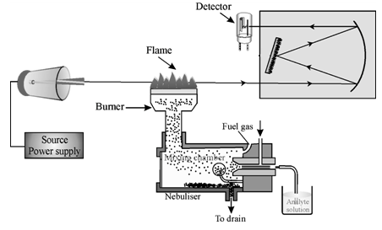

**X**

**Y**

* 1. Name the parts labelled “X” and “Y” on the above diagram. (1 mark)

**X:**

**Y:**

* 1. Describe the role of Part X in atomic absorption spectrometry. (2 marks)

* 1. Describe the role of Part Y in atomic absorption spectrometry. (1 mark)

* 1. If the instrument was set up to detect copper, would the presence of lead in the sample interfere with the results? Explain why/why not. (3 marks)

1. **(5 marks)**

Sodium is an essential element in our diets. However, the amount of sodium present in some foods is often much higher than levels recommended by doctors. A sauce was analysed using atomic absorption spectroscopy to determine the sodium content.

A 25.00 mL sample of sauce was diluted with water until the volume of the diluted sample was 1.00 L.

Four aqueous samples of known NaCℓ concentration were also prepared as standard solutions. The absorbances of the four standard solutions and the diluted sauce solution were measured. The results are given in the table below.

|  |  |
| --- | --- |
| **Concentration of Na+(aq)** | **Absorbance** |
| 100 mg/L | 0.046 |
| 200 mg/L | 0.096 |
| 300 mg/L | 0.143 |
| 400 mg/L | 0.195 |
| diluted sauce | 0.160 |

* 1. Use the above data for the Na+(aq) standards to plot a calibration line on the graph below. (2 marks)

0.20

0.15

0.10

0.05

0

absorbance

concentration of Na+(aq) in mg/L

100

300

400

200

* 1. Use your calibration graph to determine the sodium ion concentration in: (3 marks)  
     1. the diluted sample of the sauce
     2. the original (undiluted) sauce

1. **(5 marks)**

A pure gaseous sample of element Z is introduced into a mass spectrometer, and the spectrum below is generated:

A mass spectrum such as the one shown above can be used to calculate the relative atomic mass of the element being analysed.

* 1. What is meant by the term ‘relative atomic mass’. (1 mark)

* 1. Use the graph to calculate the relative atomic mass of element Z. Show all working. (2 marks)

* 1. Using your periodic table, identify and name element Z. (1 mark)

* 1. Write the formula of the major isotope of this element in the form of ${}_{Z}^{A}X$. (1 mark)

1. **(6 marks)**

Our understanding of the atom has been developed over time through the work of scientists such J. J. Thomson and James Chadwick. Describe the contributions that each of these scientists have made to atomic theory. Your answer should briefly outline the experiments they performed, their findings, and how this information was used to develop an atomic model.

**J. J. Thomson** (3 marks)

**James Chadwick** (3 marks)

**SPARE WORKING SPACE**

If you need to use this space to continue an answer, indicate in the original answer space that your question is continued on this page.

**SPARE WORKING SPACE**

If you need to use this space to continue an answer, indicate in the original answer space that your question is continued on this page.

**SPARE GRAPH**

**Question 15a)**

0.20

0.15

0.10

0.05

0

absorbance

concentration of Na+(aq) in mg/L

100

300

400

200